Firewall in CentOS Stream 9 (firewalld)

1️ What is a Firewall?
A firewall is a security system that controls network traffic.
It decides:
- Which traffic is allowed
- Which traffic is blocked
Simple Example:
- Allow: SSH (port 22)
- Block: All other unknown traffic

2️⃣ What is firewalld in Linux?
firewalld is the default firewall service in CentOS Stream 9.
Why firewalld?
- Zone-based security
- Easy to manage with firewall-cmd

3️⃣ Firewall Architecture (Very Important)
firewalld works using:
Zones
Zones define trust levels for network connections.
Common zones:
- public → Default, untrusted network
- trusted → All traffic allowed
- block → Rejects packets
Default zone in CentOS 9: public

4️⃣ Check firewalld Status
systemctl status firewalld
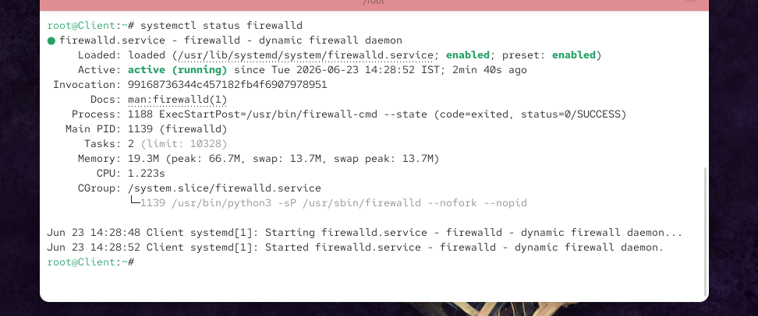
Check if firewall is running:
firewall-cmd –state
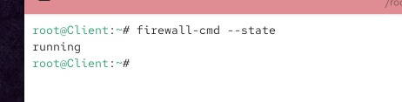

5️⃣ Enable & Start Firewall
Enable at boot:
systemctl enable firewalld
Start firewall now:
systemctl start firewalld

6️⃣ Stop, Disable & Restart Firewall
Stop firewall:
systemctl stop firewalld
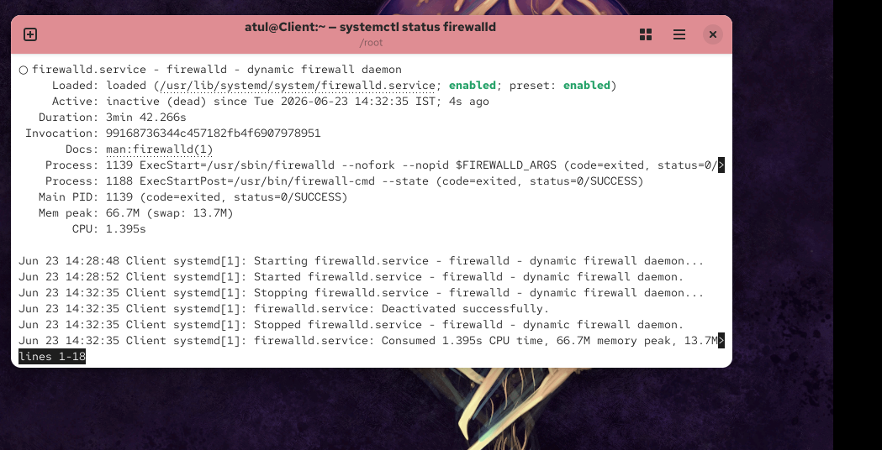
Disable firewall (not recommended in production):
systemctl disable firewalld
Restart firewall:
systemctl restart firewalld

7️⃣ Reload Firewall (Most Important)
Whenever you add/remove rules:
firewall-cmd --reload

1) Change interface to trusted zone
sudo firewall-cmd --get-default-zone

If your interface is ens160:
sudo firewall-cmd --permanent --zone=trusted --change-interface=ens160
sudo firewall-cmd --reload
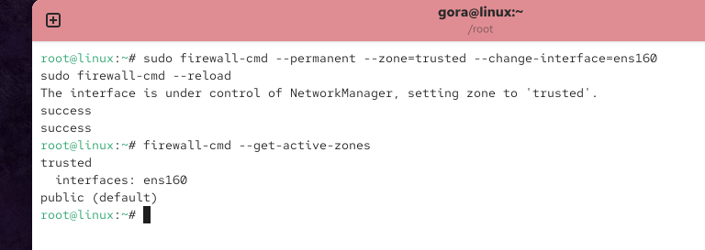

2) Change it back to default zone (public)
If you want to move the same interface back to public:
sudo firewall-cmd --permanent --zone=public --change-interface=ens160
sudo firewall-cmd --reload

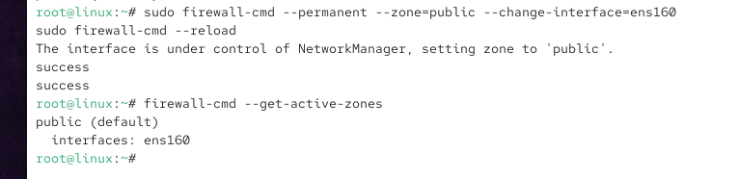

8️⃣ Check Active Zone
firewall-cmd --get-active-zones
Check default zone:
firewall-cmd --get-default-zone
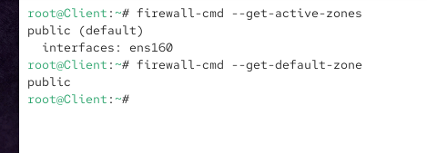

9️⃣ View Existing Firewall Rules
View all rules in default zone:
firewall-cmd --list-all
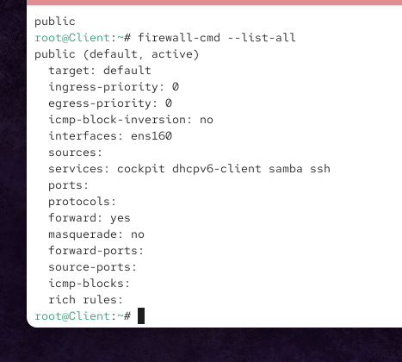
View rules in public zone:
firewall-cmd --zone=public --list-all
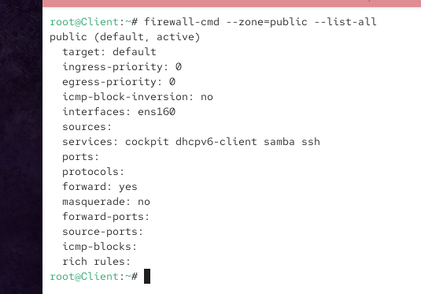

🔟 Add Firewall Rules (Allow Traffic)
1️⃣ Allow SSH (Port 22)
firewall-cmd --add-service=ssh
firewall-cmd --reload
firewall-cmd --zone=public --list-all

Permanent:
sudo firewall-cmd --permanent --add-service=ssh
firewall-cmd –reload
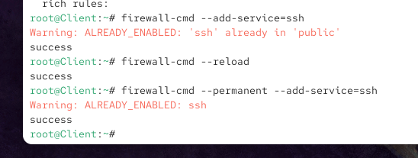

2️⃣ Allow HTTP (Port 80)
sudo firewall-cmd --permanent --add-service=http
sudo firewall-cmd –reload
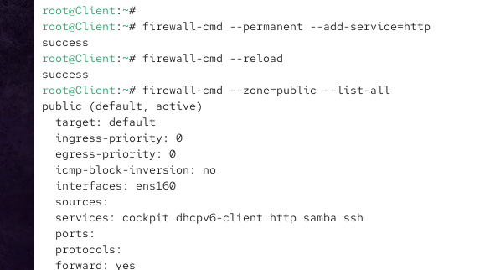

3️⃣ Allow Custom Port (Example: 8080)
sudo firewall-cmd --reload
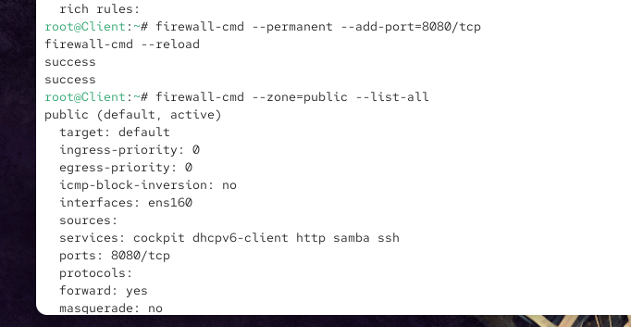

1️⃣1️⃣ Remove Firewall Rules
Remove HTTP:
firewall-cmd --permanent --remove-service=http
firewall-cmd --reload
Remove Port 8080:
firewall-cmd --permanent --add-port=8080/tcp
firewall-cmd –reload
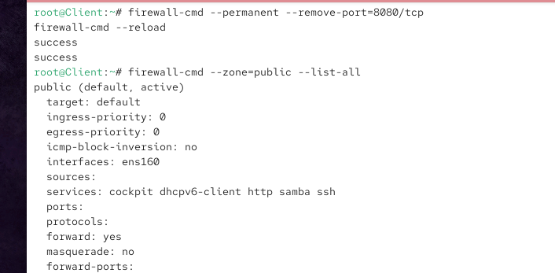

1️⃣2️⃣ Block Incoming Traffic
Block a Specific Port (Example: 22)
firewall-cmd --permanent --remove-service=ssh
firewall-cmd --reload
to see particular service is added or not?
sudo firewall-cmd --permanent --query-service=http

Block All Incoming Traffic (Drop Zone)
firewall-cmd --set-default-zone=drop
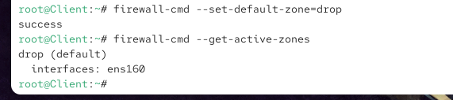
firewall-cmd --get-active-zones
Re-enable normal traffic:
firewall-cmd --set-default-zone=public
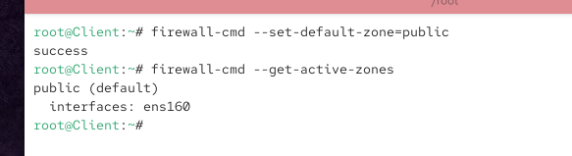

1️⃣3️⃣ Block Outgoing Traffic (Advanced – Rich Rules)
Example: Block outgoing traffic to facebook.com
host -t a www.facebook.com
firewall-cmd --direct --add-rule ipv4 filter OUTPUT 0 -d 57.144.242.1 -j DROP
firewall-cmd --reload

Block that IP
Suppose the IP is:
157.240.241.17
Run:
sudo firewall-cmd --permanent --direct --add-rule ipv4 filter OUTPUT 0 -d 57.144.242.1 -j REJECT
firewall-cmd --reload

Remove the rule later
If you want to allow Facebook again:
sudo firewall-cmd --permanent --direct --remove-rule ipv4 filter OUTPUT 0 -d 57.144.242.1 -j REJECT
Then:
sudo firewall-cmd --reload
Verify:
sudo firewall-cmd --direct --get-all-rules

Break it down
Part | Meaning
firewall-cmd | Command used to configure firewalld
--direct | Add a direct rule to the underlying firewall rules
--add-rule | Add a new firewall rule
ipv4 | This rule applies to IPv4 traffic
filter | Use the Linux filter table
OUTPUT | Applies to traffic leaving your server
0 | Rule priority
-d 57.144.242.1 | Destination IP is 57.144.242.1
-j DROP | Drop/block the packet

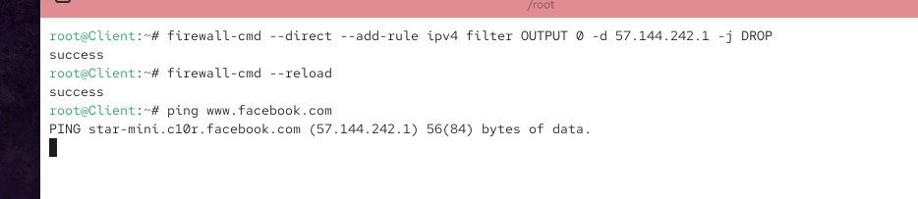
To allow connection to facebook.com
firewall-cmd --permanent --direct \
--remove-rule ipv4 filter OUTPUT 0 -d 57.144.242.1 -j DROP
firewall-cmd --reload
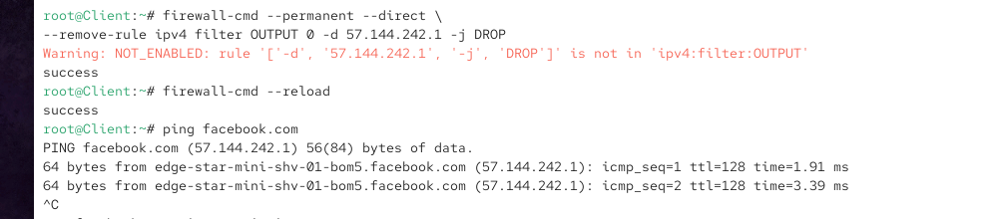

1️⃣4️⃣ Block ICMP (Ping)
Block ping requests:
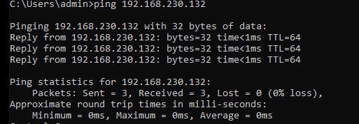
sudo firewall-cmd --permanent --add-icmp-block=echo-request
firewall-cmd --reload

Break it down
Part | Meaning
sudo | Run the command with root/administrator privileges
firewall-cmd | Command-line tool to configure firewalld
--permanent | Make the change permanent, so it remains after reboot
--add-icmp-block | Add an ICMP message type to the firewall's blocked list
echo-request | ICMP packet used when another machine sends a ping

Test:
ping <server-ip>
❌ Ping will fail
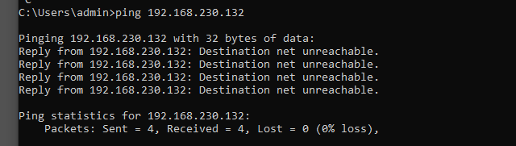

Enable Ping Again:
sudo firewall-cmd --permanent --remove-icmp-block=echo-request
firewall-cmd –reload
to see if this command is block the ping or not
sudo firewall-cmd --query-icmp-block=echo-request

4️⃣ Restore Default firewalld Configuration
cp -r /usr/lib/firewalld/* /etc/firewalld/

5️⃣ Start firewalld Again
systemctl start firewalld
Enable at boot:
systemctl enable firewalld

6️⃣ Reload Firewall
firewall-cmd --reload

7️⃣ Set Default Zone to Public (Just to Be Safe)
firewall-cmd --set-default-zone=public

8️⃣ Verify Everything is Default
firewall-cmd --list-all
Expected output will look like:
- zone: public
- services: (only default ones)
- ports: (empty)
- rich rules: (none)
- icmp-blocks: (none)

9️⃣ Extra Safety Check (Students Love This)
firewall-cmd --get-default-zone
firewall-cmd --get-active-zones
firewall-cmd --list-rich-rules
firewall-cmd --list-icmp-blocks
All should be clean / empty.

🔟 ONE-COMMAND QUICK RESET (LAB ONLY ⚠️)
⚠️ Use ONLY in lab machines, not production
systemctl stop firewalld && rm -rf /etc/firewalld/* && cp -r /usr/lib/firewalld/* /etc/firewalld/ && systemctl start firewalld

